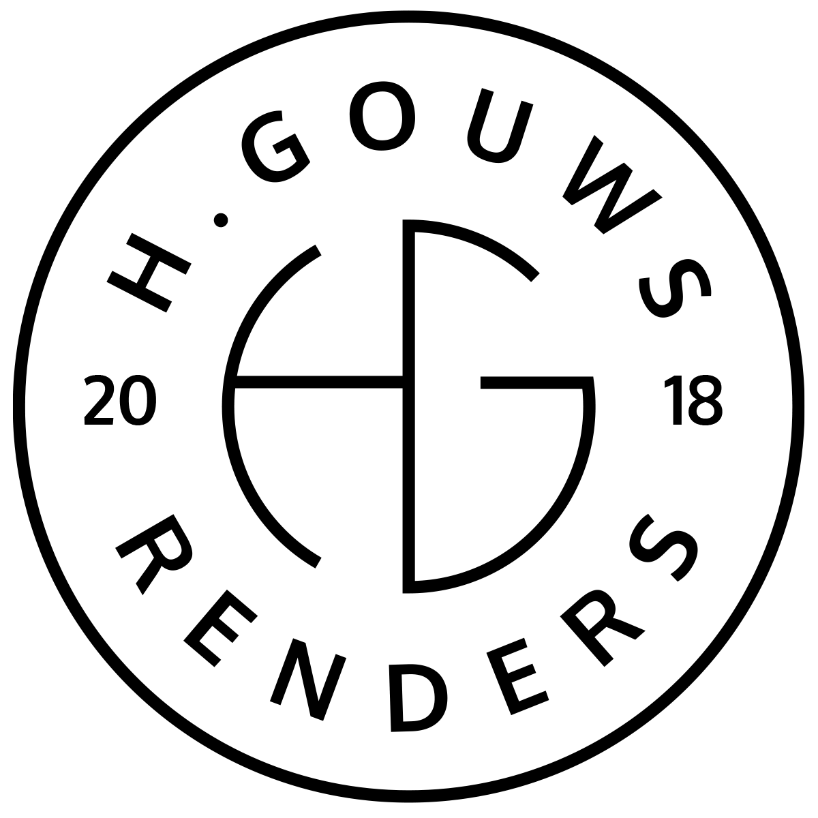H. Gouws Renders PTY LTD:
2020/784683/07
T/A: H. Gouws Renders and Designs

Unit 10 – The Network
19 Cactus Road
Fairview
Port Elizabeth (Gqeberha)
Eastern Cape
2075

Client:
Riaan Esterhuizen
101 Lucas Street
Newton Park
Port Elizabeth
6045

INVOICE:
000382022ESTERH
Date: 09 MARCH 2022

Item: | Description: | Quantity: | Price: | Total:
-------------------------------------------------------------------------------------------------------
1 | House Esterhuizen: 50% Design Deposit. | 0.5 | R52 331.84 | R26 165.92

-----------------------------------------------------------------------------------------------------------------------------------
TOTAL:
VAT NOT APPLICABLE R26 165.92 ex VAT

Banking details:
Nedbank
Account Number: 1212774191
Branch Code: 12681700
Cheque account

KINDLY USE THE INVOICE NUMBER AS YOUR PAYMENT REFERENCE

