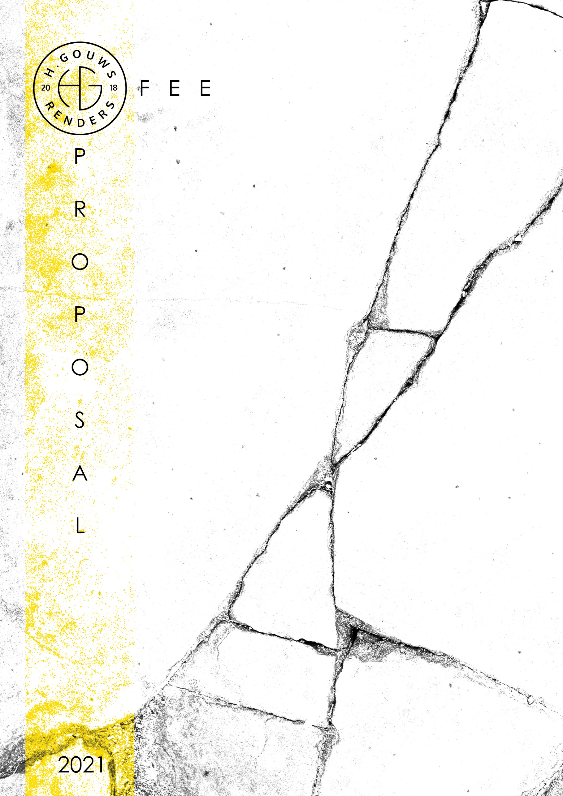

H. Gouws Renders PTY LTD:
2020/784683/07

1 Elsa Joubert street
Fairview
Port Elizabeth (Gqeberha)
Eastern Cape
2075

Client:
Stiaan Herbst
Date: 08 July 2021
|SCOPE OF WORKS:
Model and provide renders for project:
House HERBST
Project Requirements:
- Model and furnish the Master bedroom + En-suite and provide 2 x High resolution renders
  - Provision to be made for furniture to be replaced, resulting in re-renders.

- Model and furnish living spaces (kitchen, lounge, and bar) and provide 1 x High resolution renders.
  - Provision to be made for furniture to be replaced, resulting in re-renders.

|QUOTE:
House HERBST:
- 3 x Views / Renders. (1 x Master Bedroom, 1 x Master En-suite, 1 x Kitchen)
- This quote allows for 1 x re-render/furniture replacement after the first handover, all renders after this with changes in furniture will be quoted at R1000 per re-render, to be invoiced on the last day of each month or when the project has reached completion, whichever comes first.
- Post production changes, like colour amendments on walls, will be charged at R500 per render.
TOTAL QUOTE: _________________________________R20 000.00 ex VAT
50% Deposit payable at inception, with the balance payable at Final handover, or full payment at project inception.
|ACCEPTANCE:
The Terms and Conditions presented here may be modified or amended as necessary only by written instrument signed by both parties.

By submitting the deposit payment, you are agreeing to the terms and conditions detailed above. This proposal is agreed upon in full, signed and dated.

By signing this document, I indicate that I understand, agree to and accept the terms and conditions as contained herein, dated this 08 JULY 2021.

I, __________________________________________ hereby agree to the Terms and Conditions laid out in this document.
Date:
Signature / Digital Signature:

Email: hgouws.renders@gmail.com
Cell: 072 799 9597
Instagram: @hgouws.renders
Facebook: H. Gouws Renders (@hgouws.renders)

Thank you for the opportunity to quote on your project.

Keep well, and chat soon.
Thank you.

Kind Regards

Hannes Gouws
3d Artist | Professional Senior Architectural Technologist | PSAT 32449887

