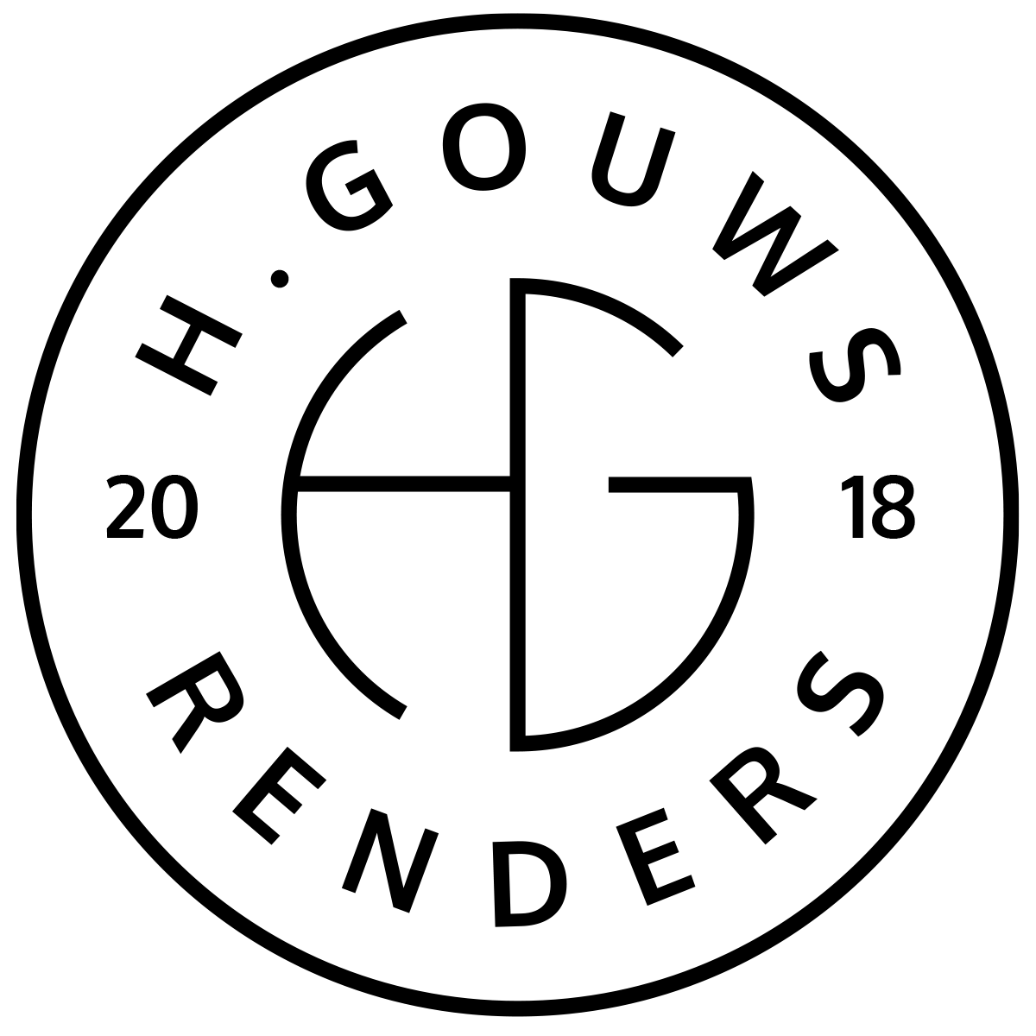H. Gouws Renders PTY LTD:
2020/784683/07

1 Elsa Joubert Street
Fairview
Port Elizabeth (Gqeberha)
Eastern Cape
2075

Client:
Dr. Johan Scherman
johan@healthgroup.co.za
082 588 6682
Zoetvlei
Paterson
Vat nr. 4630294058
INVOICE:
000302021ZOETVLEI
Date: 18 NOVEMBER 2021

Item: | Description: | Quantity: | Price: | Total:
-------------------------------------------------------------------------------------------------------
Zoetvlei Wildlife Estate Phase 1: Phase 1: 2021 Site Layout
-----------------------------------------------------------------------------------------------------------------------------------1 | Phase 1: 2021 Site Layout | 1.0 | R15 000.00 | R15 000.00

-----------------------------------------------------------------------------------------------------------------------------------
TOTAL:
R15 000.00 ex VAT

Banking details:
Nedbank
Account Number: 1212774191
Branch Code: 12681700
Cheque account

KINDLY USE THE INVOICE NUMBER AS YOUR PAYMENT REFERENCE

